Teacher Evaluation System Frequently Asked Questions
In accordance with Ohio Revised Code and State Board of Education Framework

Ohio’s Teacher Evaluation Model
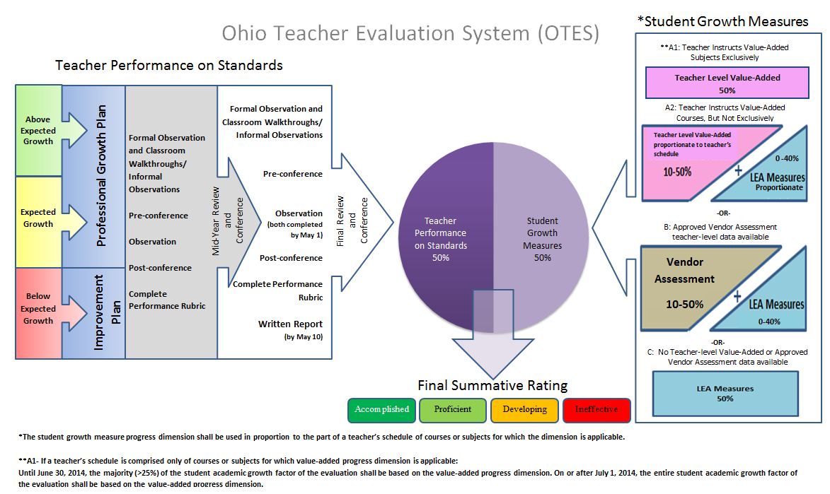
The OTES model is designed to provide support for the implementation of the Ohio State Board Of Education approved framework. It is representative of three years of committee work that includes a field test and pilot. This model is a professional growth model and is intended to be used to continually assist educators in improving teacher performance. This process is to be collaborative and in support of the teacher.
Teacher performance is determined by using a rating rubric (Teacher Performance Evaluation Rubric) consisting of indicators based on the Ohio Standards for the Teaching Profession. The evaluation process requires the evaluator to use evidence gathered in a variety of avenues (professional growth or improvement plan, observations, walkthroughs, and conferences) to determine a teacher performance rating.
- 50% Teacher Performance based on Teacher Performance Evaluation Rubric
- 50% Student Growth Measures in accordance with House Bill 555 (see HB 555 FAQs)

Teachers with above expected levels of student growth will develop a professional growth plan and may choose their credentialed evaluator for the evaluation cycle.

Teachers with expected levels of student growth will develop a professional growth plan collaboratively with the credentialed evaluator and will have input on their credentialed evaluator for the evaluation cycle from a list approved by the local board.

Teachers with below expected levels of student growth will develop an improvement plan with their credentialed evaluator. The administration will assign the credentialed evaluator for the evaluation cycle and approve the improvement plan.

Teacher Evaluation Implementation
Q: If our LEA is not in Race to the Top, School Improvement Grant or Teacher Incentive Fund, what work should we be doing?
A: ORC 3319.111 – No later than July 1, 2013, the board of education of each school district, in consultation with teachers employed by the board, shall adopt a standards-based teacher evaluation policy that conforms with the framework for evaluation of teachers developed under section 3319.112 of the Revised Code.

So, if you are not a RttT, SIG, or TIF school, you should be working on adopting a policy for your district and re- aligning your district’s evaluation procedures to match.

Q: Our district will adopt a policy for educator evaluation by July 1, 2013. When do we have to implement the evaluation system? Our bargaining agreement will not expire until after 2013.
A: Since there are several different legislative effective dates as well as differences in collective bargaining agreements, it is best to consult your LEA’s legal counsel to determine how ORC applies to individual LEAs.

Evaluation Model: Teacher Performance on the Standards
Q: What are the required forms?

A: There are no required forms. LEAs are required to align to the state framework, the performance rubric, and collect evidence to support the ratings. An overall rating, which is fifty percent, in combination with the fifty percent SGM rating will be calculated as a Final Summative Rating and will be reported in aggregate to ODE through eTPES.

Q: Why are certain things included in the rubric? How was it determined what would go into this rubric?

A: The scope of work of the Ohio Teacher Evaluation Writing Team during 2009-2010 included extensive study of model evaluation systems throughout the country. Many state systems were examined in depth (e.g., District of Columbia Public Schools, Delaware, New Mexico, Colorado) for a standards-based definition of teacher effectiveness. Research was supplemented by the work of Charlotte Danielson, Laura Goe, New Teacher Center, and Learning Point Associates. The writing team used the Ohio Standards for the Teaching profession as the foundation for determining areas to be included in the rubric. From this work, the rubric was developed. A review was then conducted by national experts. Input received during field testing and piloting further refined the rubric.

Q: If an LEA does not use OTES and wants to use its own evaluation system, what steps do they have to take to be able to use their own evaluation system?

A: All evaluators in Ohio, regardless of the evaluation system they use, will have to complete state sponsored training and pass an online assessment. Their performance rubric will need to be aligned with the OTES rubric. The LEA must complete the alignment tool found in the eTPES as well as report their ratings in the electronic system.

Q: Why does the rubric say “and/or” if all areas must be met? Do all indicators on the rubric have to be evaluated?

A: All indicators on the rubric do not have to have evidence associated with them. However, it is important that the evaluator have enough evidence to make a determination of the rating for that teacher.

Q: How will the rubrics be used to focus professional development for teachers and administrators?

A: At the beginning of the school year, the educator will complete a professional growth plan or have an improvement plan completed. In these plans, there should be areas determined for professional development. A self-assessment against the Ohio Standards for the Teaching Profession may be completed by the teacher prior to developing the professional growth plan to provide a complete picture of their teaching practice.

Each educator should engage in a post-conference. During that conference, the evaluator should offer area(s) of reinforcement and area(s) of refinement. These areas of refinement will guide improvement and professional development.

Q: Are the pre-conferences and post-conference required?

A: No, they are considered best practice. Growth comes from the conversations about practice between observer and teacher.
Q: Do both formal observations have to be scheduled/ announced?
A: This is an LEA decision.

Q: Does the evaluator have to script during the observation?

A: The scripting provides concrete evidence for the evaluator to cite in the evaluation documentation and supports the rating provided. However, scripting is not required.

Evaluation Model: Student Growth Measures for Teachers
Q: If I am a teacher with no value-added data, will my district need to purchase one of the vendor assessments?
A: No.
Districts are not required to purchase vendor assessments. If a teacher has ODE approved, vendor assessment data, then that data will need to be used in the student growth measures calculation. If a teacher has value- added data, then the value-added data must be used in the student growth measures calculation. For teachers without value-added or approved vendor assessment data, local student growth measures will be used.

Q: I need more information on student growth measures. Where do I find that information?
A: There is a link on the ODE website that includes an overview of student growth measures, the ODE approved list of assessments, student learning objectives information and tools, and steps for designing local student growth plans for evaluation. Additional information is added to this part of our website regularly.

http://education.ohio.gov/GD/Templates/Pages/ODE/ODEDetail.aspx?page=3&TopicRelationID=1230&ContentID=125742

Credentialing
Q: Who needs to attend the Ohio Teacher Evaluation System (OTES) state-sponsored training?
A: Every evaluator of teachers must attend the state-sponsored training and pass the online assessment in order to become credentialed and conduct teacher evaluations.
Credentialed Evaluators
- Possess the proper certification/licensure to be an evaluator or are LEA trained and approved peer evaluators
- Have been approved as an evaluator by the local board of education
- Have completed state-sponsored OTES training
- Have passed the online assessment using the OTES Performance Rubric.

The state sponsored training is intended for evaluators of teachers.

Q: Will there be state-sponsored OTES training held in my area?
A: Yes.
State-Sponsored Training
- State Trainers will conduct training sessions regionally for all persons who will be evaluating teachers. This training will consist of three days face-to-face training, and an online credentialing process.
- Training sessions will be available locally. Locations for all training sessions are listed by date and location in STARS.
- Training sessions are limited to 50 participants each so it is important to be registered for the training.
- The training is offered at no cost through September 30, 2013.
- There is capacity to train over 15,000 individuals within the 2012-2013 school year, beginning in June 2012.

Q: What if my district is not using the OTES rubric for evaluation? Do I still have to go through the state-sponsored training?
A: Yes.
All districts will need to either use the Ohio Teacher Evaluation System (OTES) rubric or align to the Ohio Standards for Educators and the OTES rubric. Because of this, the training will allow for reliability and consistency with teacher evaluations across Ohio. An electronic tool for LEAs to use in order to align non-OTES rubrics is the first step in eTPES.

Q: A teacher with above expected student growth may choose his or her own evaluator. Does the evaluator have to be within the building or district? Must the evaluator agree if asked? What happens if they all choose the same person? One person may not be able to get it done.

A: The LEA will determine the list of evaluators the teacher may choose and the procedures for selecting the evaluator.

Q: Do evaluators have to pass a test every year in order to evaluate?

A: Based on current research we recognize the importance of re-calibration completed on a yearly basis to avoid many issues including rater drift. We anticipate that starting in year 2014-2015 every evaluator will need to complete an on-line re-calibration annually.

Q: What is a 3rd party evaluator?

A: ORC 3319.111 states that an evaluator may be a person who is employed by an entity contracted by the board to conduct evaluations and who holds a license designated for being a superintendent, assistant superintendent, principal, vocational director, administrative specialist or supervisor in any educational area issued under section 3319.22 of the Revised Code or is qualified to conduct evaluations. The words “3rd party evaluator” no longer appears in legislative language.

Q: Can there be more than one evaluator for the teacher?

A: ORC 3319.111 states that each evaluation conducted pursuant to this section shall be conducted by one or more of the following persons who hold a credential established by the department of education being an evaluator. The language says one or more so, yes, there can be more than one evaluator for a teacher.

Q: Why do administrators have to take this training? Principals and other administrators already have earned degrees and have coursework in supervision, isn’t that enough?

A: This training does not replace graduate coursework. The purpose of the training is to provide consistency across the state and to make sure that expectations for ratings are clear. This training is required so that common understanding across evaluation systems occurs.

Q: In the OTES training, there are only training videos of intermediate grade level teachers. Why aren’t there videos of high school teachers?

A: The training uses intermediate grade level teachers so that all evaluators can apply the information in the training. If high school only teachers were shown in the training, this may not meet the needs of the primary grade evaluator. Likewise, if a primary grade teacher video was used, it would not meet the needs of a secondary evaluator. The videos chosen allow the evaluators to focus on using the tools of the evaluation instrument in order to build understanding of the system. Once the evaluator has completed the training, there are practice videos and online assessment videos for various grade levels available on the online portal. The evaluator may choose to view any grade level band they wish at that time.

Q: Why is there emphasis on “scripting” in the training?

A: The training is emphasizing the importance of capturing objective evidence during observations. Scripting is a tool used by the evaluator to capture evidence. This evidence is needed and important to use when assigning a rating to the observation. As the evaluator becomes more familiar with the evaluation system, the evaluator will likely develop his/her own methods for collecting evidence during the observation.

Q: What if I lose my username and password to complete the credentialing process?
A: If you do not receive your username and password after a few weeks, or if you think you may have misplaced it, you can send an email to support@niet.org. They will be able to assist you in retrieving this information.

eTPES: Electronic System
- Please reference the FAQs for eTPES for additional questions.

More Information

Q: Will individual teacher’s ratings be made public?
A: No, the districts will only report to ODE the aggregate ratings. Just like previous evaluation systems, there may be public records requests for teacher evaluations at the local level.

Q: How does OTES support a teacher’s IPDP?

A: Ideally, the 5-year goal in a teacher’s IPDP should be supported through the yearly goals set for evaluation. However, it is not a requirement that they align.

Q: What are the plans to evaluate certificated personnel that are not in a classroom? (counselors, nurses, & librarians)?

A: This is a local decision and determined through the local negotiated agreement. The new teacher evaluation system applies to any person who is employed under a teaching license or under a professional or permanent teacher’s certificate and who spends at least 50% of the time employed providing student instruction. The new teacher evaluation does not apply to a person employed as a substitute.
Q: What will be the expectation for this process as it relates to preschool programs?

A: Public preschool programs in public schools are expected to have teachers evaluated under the new teacher evaluation system.

Q: Can we videotape or record teachers during the observation?

A: This would be determined in your LEA negotiated agreement.

Q: How will teachers be trained in this model? How will the teacher become educated with this new process?
A: Evaluators who have completed the credentialing process have access to already developed professional development resources through the NIET portal which can be utilized to train their staff.

Q: Is Higher Ed on board? What is being done with colleges and universities to align programs with these new evaluation expectations?

A: Higher education representatives have been participating on various ODE committees and study groups for the past three years. Beginning with the Resident Educator program, staff from IHEs have served on the RE Writing Team, serve as state trainers for mentors, and serve on an Education Service Center Consortia, working with districts on teacher training. In addition, all fifty-one institutions in the state have participated in a pilot of the pre-service teacher performance assessment (pre-service TPA), and continue to work to field test a Summative TPA for candidates graduating from teacher preparation programs. In the first two years of the Teacher Evaluation Writing Committee (2009-2011), higher education representatives participated in the development of the Ohio Teacher Evaluation System model. During the 2011-12 year, ODE staff worked with a higher education group to develop metrics for measuring the success of teacher preparation programs, “Teacher Preparation Quality Measurements.” The purpose of this data is to gauge the success of their graduates during the first three years of their teaching career, and report information to the university/college teacher preparation programs. This information and data will be used to evaluate courses within the preparation programs, and modify/revise requirements as needed.

Q: Where can I find updates and the latest information regarding teacher evaluation?
A: Go to the Ohio Department of Education website and enter keyword search –OTES (or OPES). You may access the site directly at:
http://education.ohio.gov/GD/Templates/Pages/ODE/ODEDetail.aspx?page=3&TopicRelationID=521&ContentID=108217

